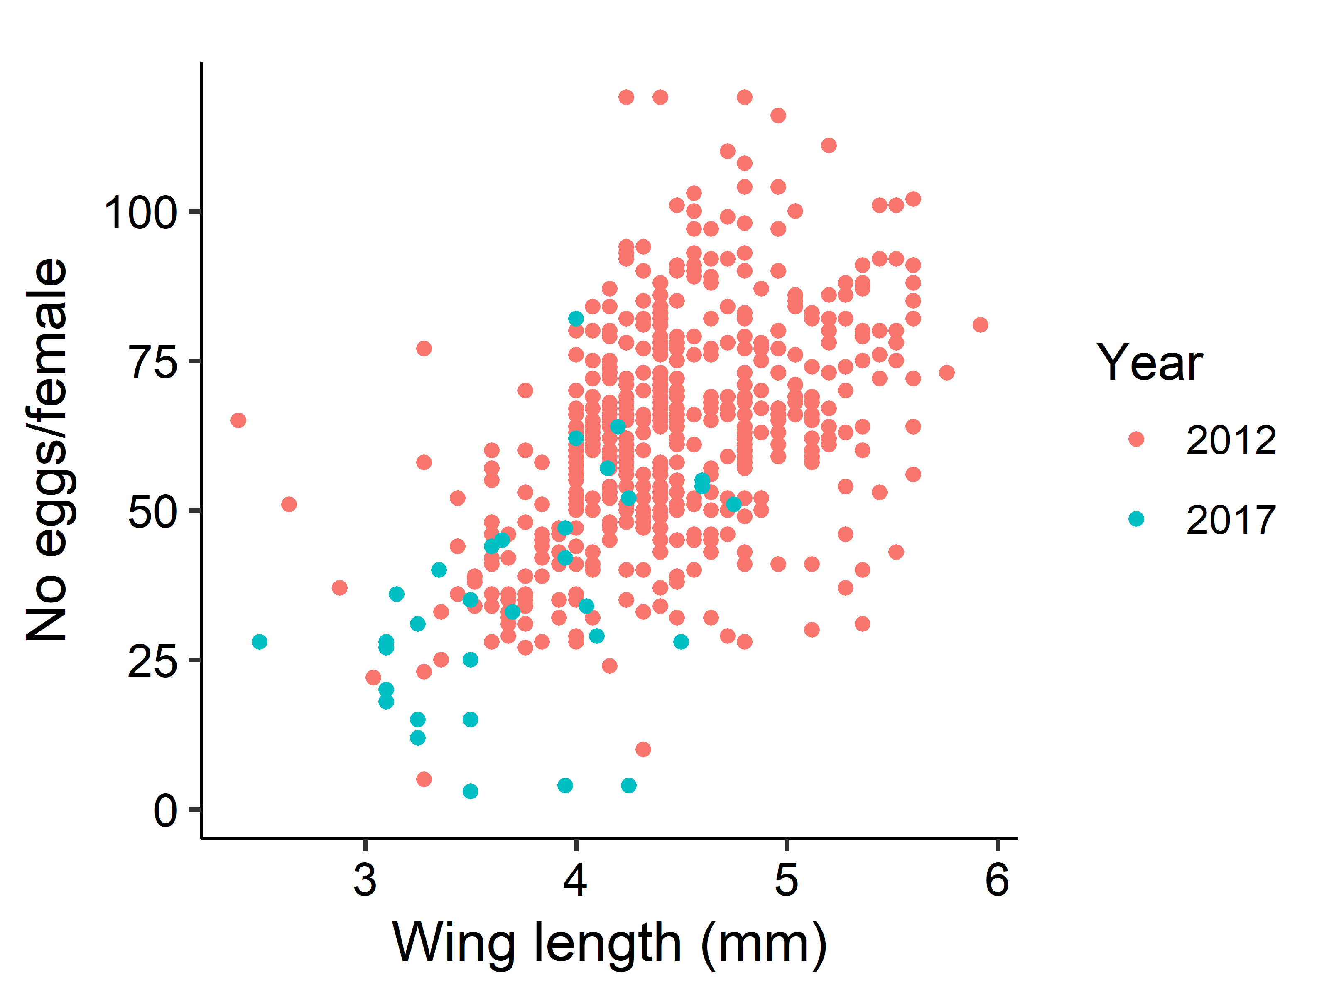

**Linear model**

Call:

lm(formula = Eggs ~ Winglength, data = eggcount)

Residuals:

Min 1Q Median 3Q Max

-54.606 -10.805 -0.482 10.179 60.580

Coefficients:

Estimate Std. Error t value Pr(>|t|)

(Intercept) -20.267 6.079 -3.334 0.000919 ***

Winglength 18.558 1.368 13.568 < 2e-16 ***

---

**Power function**

Formula: Eggs ~ a * Winglength^b

Parameters:

Estimate Std. Error t value Pr(>|t|)

a 9.116 1.414 6.448 2.64e-10 ***

b 1.286 0.102 12.606 < 2e-16 ***

---

**Linear function is slightly better**

> aictable(rawaic,nR)

Params logL AICc deltaAICc weight cumwt

wingtoegglinear 3 -2173.021 4352.082 0.0000 0.7802 0.7802

wingtoeggpower 3 -2174.288 4354.615 2.5335 0.2198 1.0000

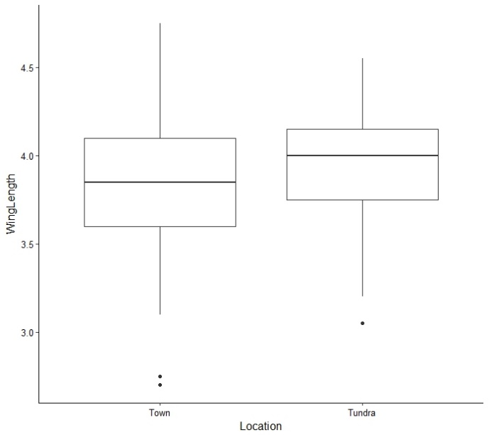

**Tundra mosquitoes are bigger**

Analysis of Variance Table

Response: WingLength

Df Sum Sq Mean Sq F value Pr(>F)

Location 1 0.455 0.45501 4.4923 0.03474 *

Residuals 358 36.261 0.10129

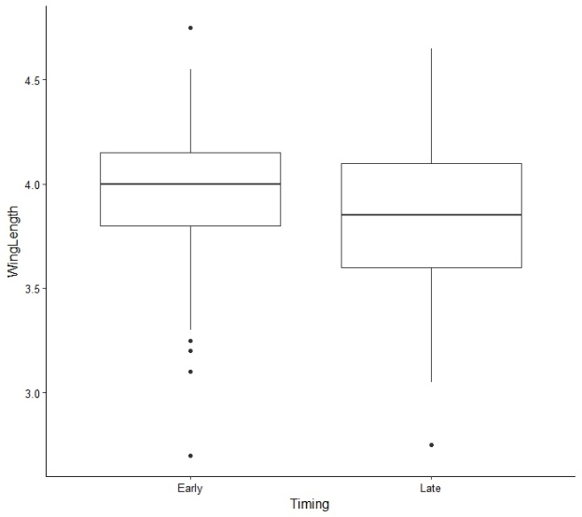

**Early mosquitoes are bigger**

> m2<-lm(WingLength~Timing, data=C02winglength)

> anova(m2)

Analysis of Variance Table

Response: WingLength

Df Sum Sq Mean Sq F value Pr(>F)

Timing 1 0.978 0.97839 9.801 0.001888 **

Residuals 358 35.738 0.09983

